Ideation Phase
Define the Problem Statements

Date | 16 June 2025
Team ID | LTVIP2025TMID59367
Project Name | OrderOnTheGo: Your On-Demand Food  Ordering Solution
Maximum Marks | 2 Marks

Customer Problem Statement Template:
Problem  Statement (PS) | I am  (Customer) | I’m trying to | But | Because | Which makes me feel
PS-1 | A hungry student or working person looking for a quick meal | Find and order food from nearby restaurants easily | Many  apps are confusing and slow, with too many  steps | They lack intuitive design and real-time updates | Frustrated, impatient, and likely to abandon the order
Many customers today face frustration when ordering food online due to slow interfaces, confusing menus, lack of real-time updates, and limited restaurant options. They often struggle to find nearby restaurants that suit their taste, apply discounts easily, or complete an order without unnecessary steps. Customers expect a smooth, fast, and intuitive experience that allows them to explore food options, customize their orders, and receive accurate order updates. A platform that eliminates these pain points and makes the entire food ordering journey enjoyable and efficient is highly needed.
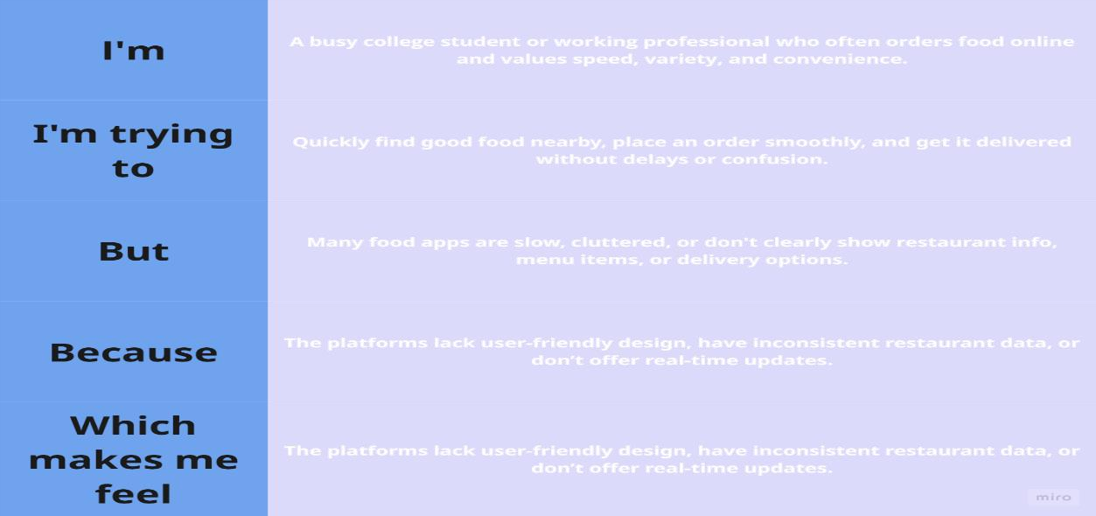
Example:

PS-2 | A user who regularly orders food online | Explore restaurant options, check offers, and place an order smoothly | Offers aren’t visible  clearly and restauran  t info is  outdated | The platform doesn't prioritize  clarity and updated data | Disappointed and less likely to return to the platform

